# Project Name: Online Test Application.

### Landing page:

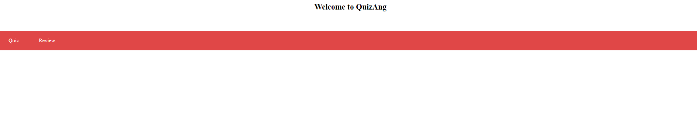

### Quiz Page:

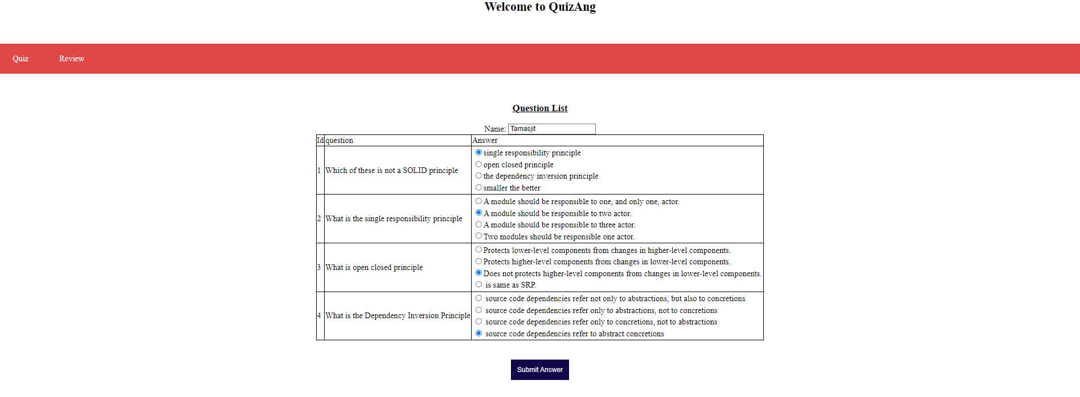

### Review of given Ans:

### Review Page:

